Summary - A study was conducted by Huang Li and Bradely to investigate how financial analysts serve their information intermediary role by conducting a large-scale comparison of the textual content of analyst research reports to that of closely preceding corporate disclosures.

Slide one : Financial analyst play an important role and one of their roles is the informational intermediary role whereby they provide research summary to investors which typically has the qualitative and quantitative side and thier outputs provide value to capital market participants.

-As informational intermediaries F. A can play their role through private research efforts and generate information that is not readily available to investors OR BY HELPING INVESTORS to understand existing info by clarifying it. These efforts are termed the Discovery role and info interpration role.

-the study introduced a new textual technique to construct measures of analyst and then they uses a topic modeling approach called latent Dirichlet allocation (LDA) and with that they were able to extract topics from analystist report AA and conference calls CC and conduct battery validity test to verify the effectiveness of LDA. with that they found that analysts spend an average of 31% of their discussion on exclusive topics that receive little or no mention by managers, and thus 69% of their discussion focuses on conference topics. This suggests that both analyst information discovery and interpretation roles are substantial.

-LDA provides offers several advantages over manual coding. Its less expensive because the massive collection of document that it is capable of producing, it will be expensive if coding did the same job

Second, LDA provides a reliable and replicable classification of topics. Which isnt available for manual coding.

Third, LDA does not require researchers to prespecify rules or keywords for the underlying taxonomy of categories.

Table 1 presents the 20 most frequent words in each of the top 10 topics in the capital goods and health care equipment and services industries

This table validats the effectiveness of the LDA algorithm in identifying distinct, economically meaningful topics in conference calls and analyst reports.

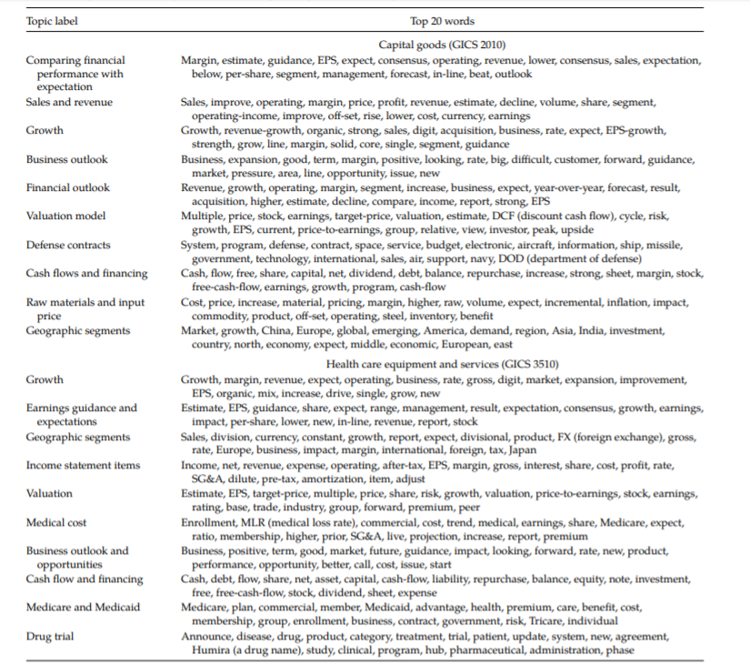

The next thing the study wanted to validate is whether Investors Value Analyst Information Discovery and Interpretation Roles?

Using this formula

CAR[0, 1] α1Tone_Discovery+ β1Tone_Interpret + γ1Tone_CC +Controls+ ε,

In this formula tone discovery is the favorableness of analyst opinion in new topics in analyst reports and tone interpret is favorableness of analyst opinion in conference calls and from the subtraction we find tone_cc

The summary statistics reported in show that both mean values of Tone_Discovery and Tone_Interpret are positive (0.188 and 0.217, respectively), consistent with the overall analyst optimism documented in the literature.

The next aspect that the paper wanted to find possibility that analyst research reports provide value to investors without discovering new information or interpreting corporate disclosure using new languages.

To do so a test was designed using the Pearsons Chi square test to test whether the words used by managers and analysts to discuss a given topic are statistically different. From the test they found that

We find that there is a positive and significant coefficients for all tone variables. indicates the confirming value provided by analysts. That is, by selectively repeating CC topics, analysts attract and direct investors’ limited attention to what is important from managers— confirming these topics’ usefulness

Conclusion

In conclusion we know that after coporate disclosure events analysts issue lots reports immediately

We found that We find that, on average, 31% of an analyst prompt serves an information discovery role. And 69% of the discussion in a prompt serves information interpretation role

invest